**Setting up a Google Cloud Platform Environment**

**Creating The Project:**

Before you can start building anything on Google Cloud Platform, **you first need a project.** Projects allow you to easily organize all the resources in your account. Every time you create a compute, storage or network resource, you will need to assign it to a project. Projects also contain their own unique set of users, APIs, and billing account information.

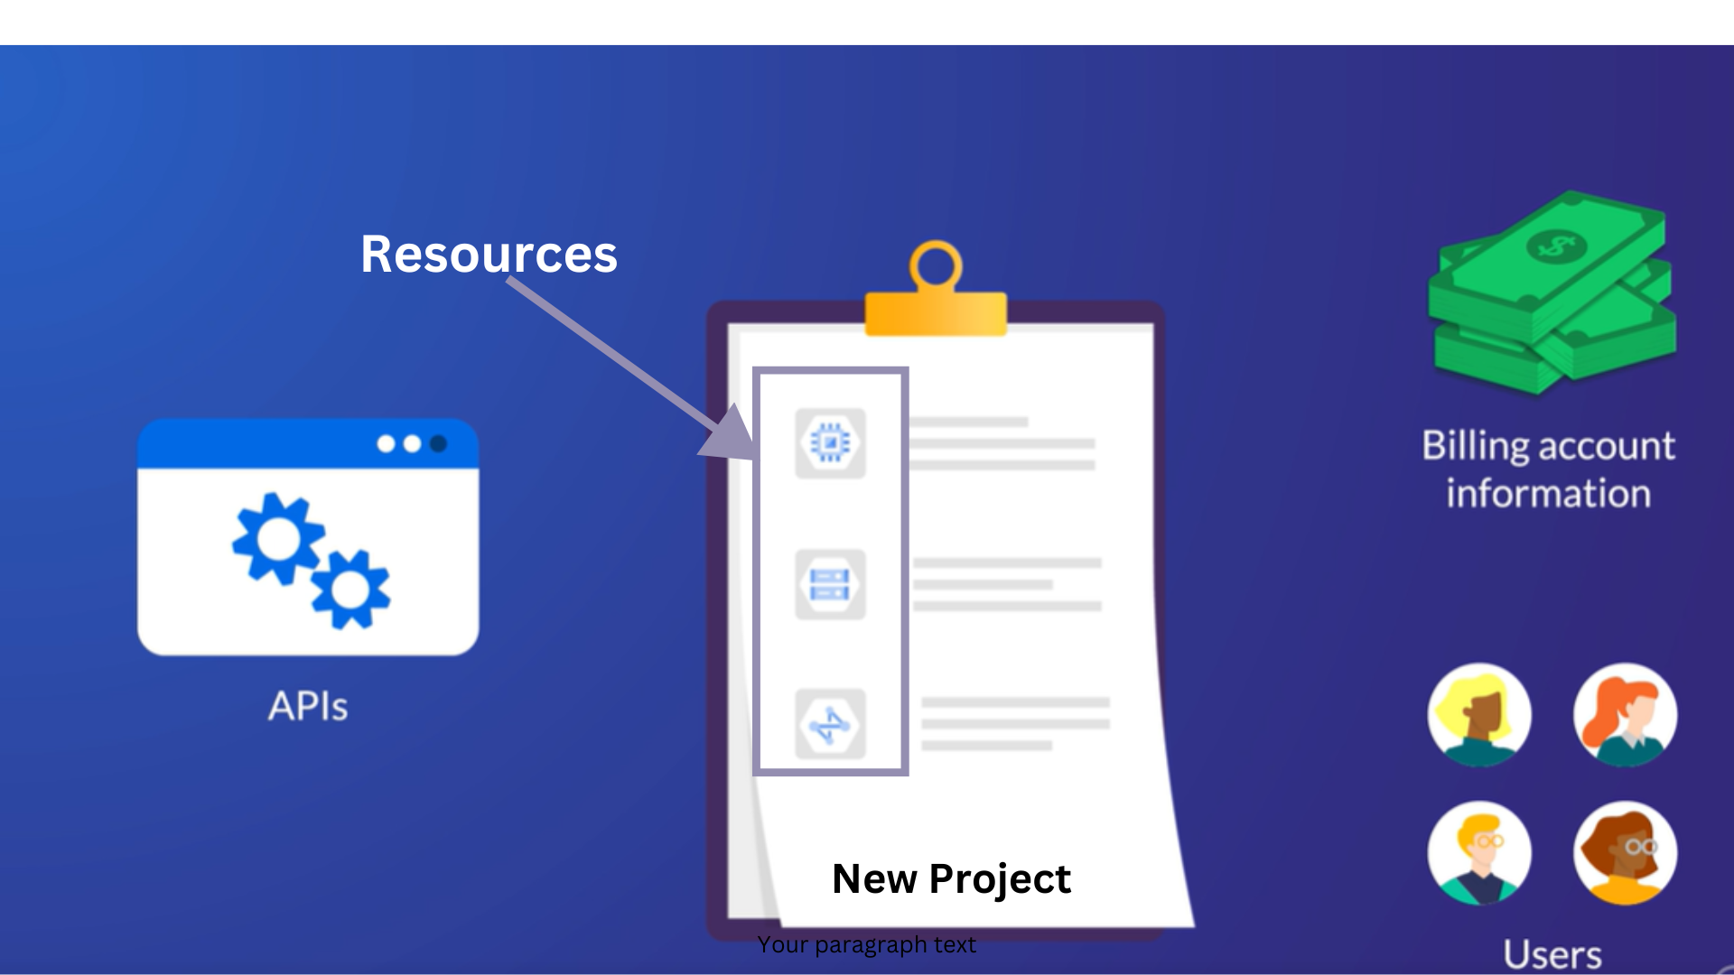

**Creating the Project:**

When creating a GCP account, a default project will be created with the name *“My First Project”*.

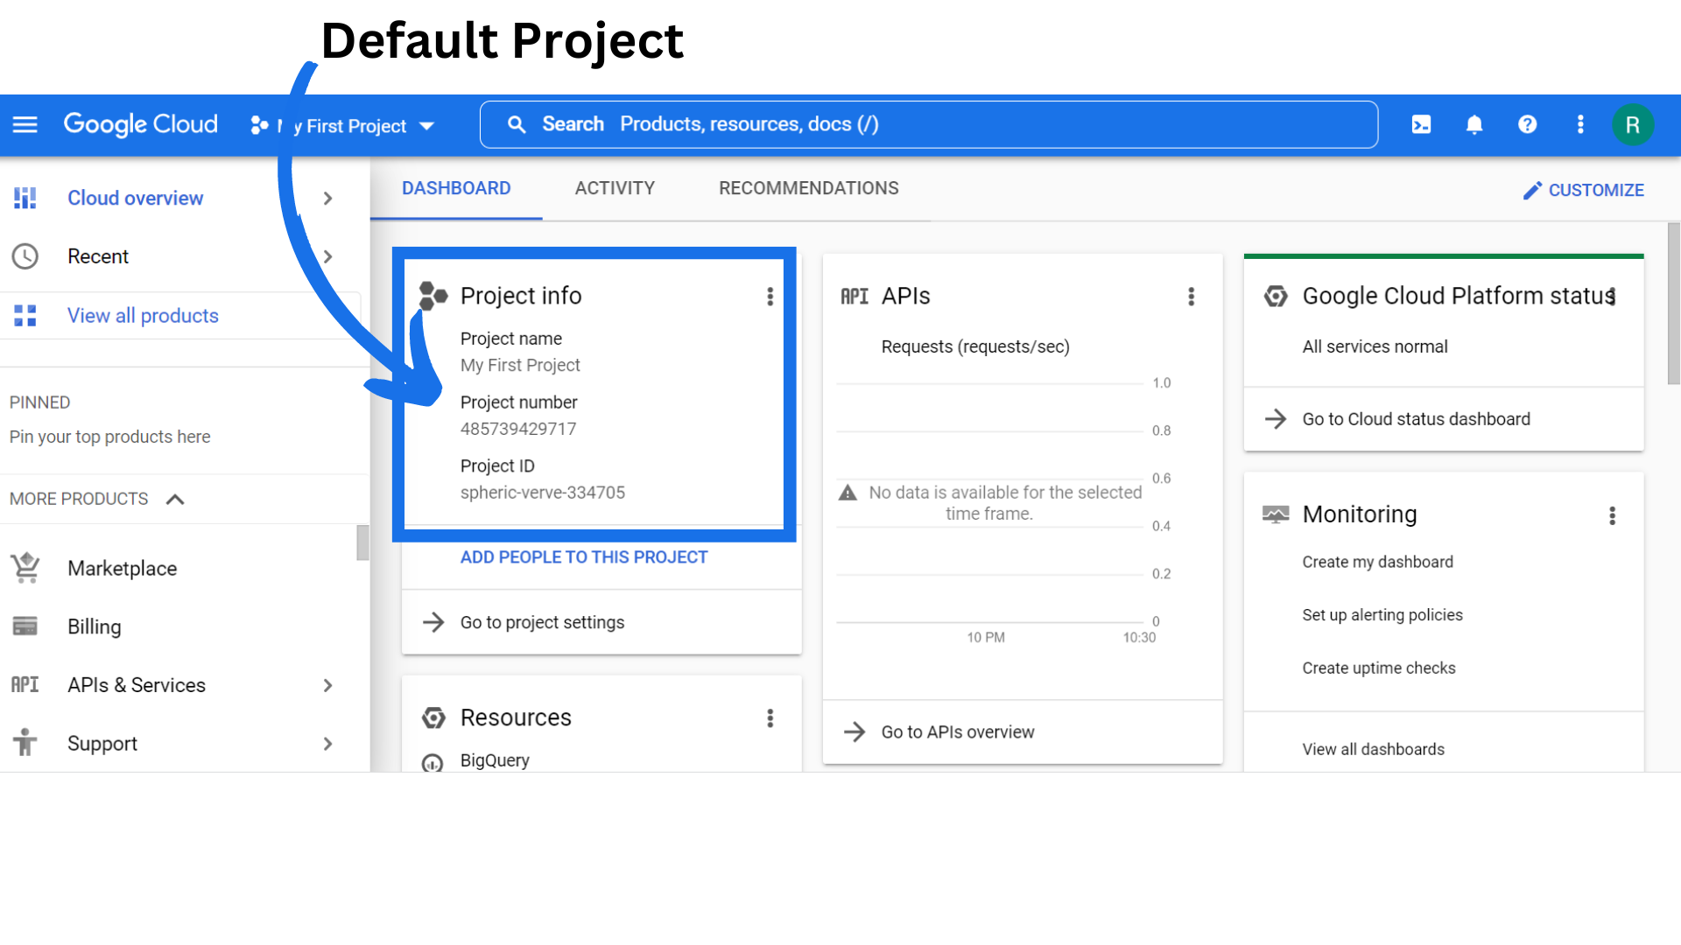

1. Once you first log in, your screen should look similar to this.

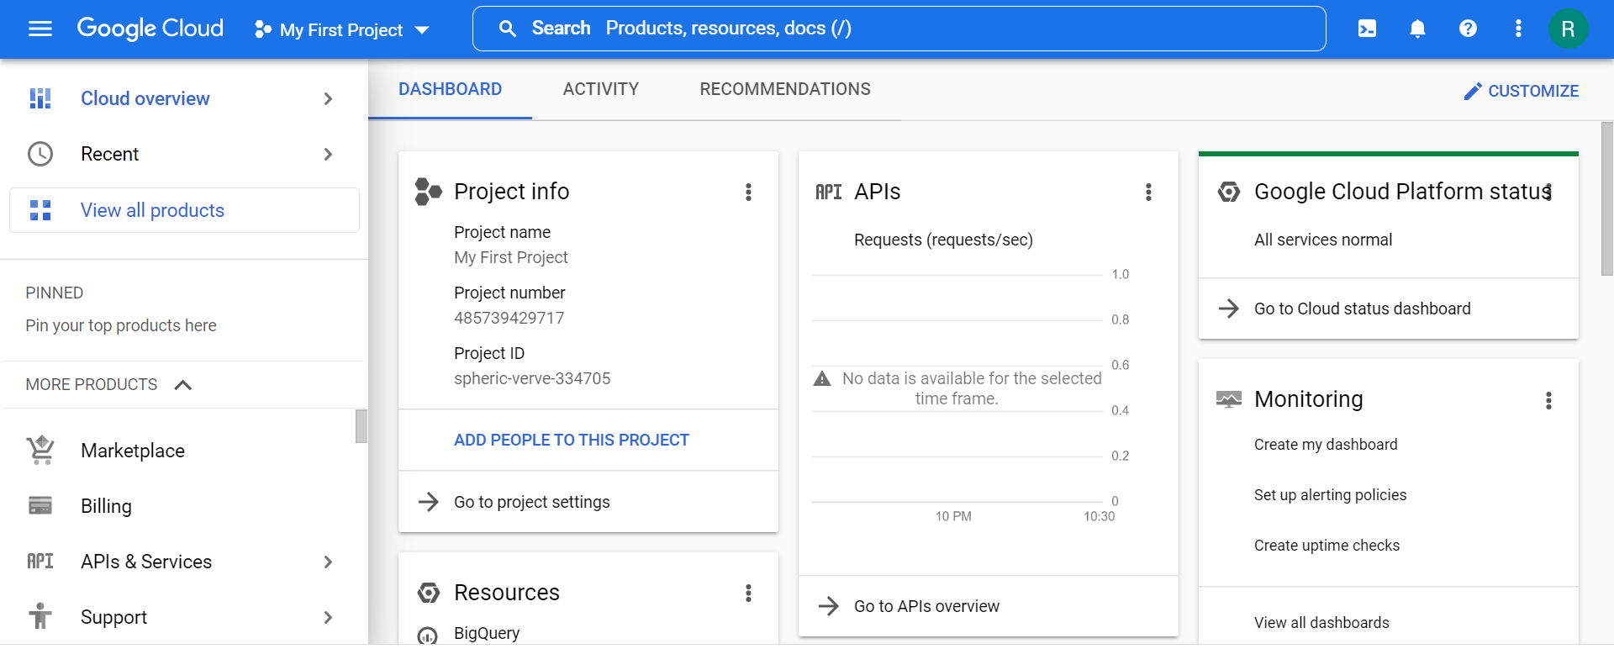

1. Click on the project selector drop-down menu at the top of the screen.

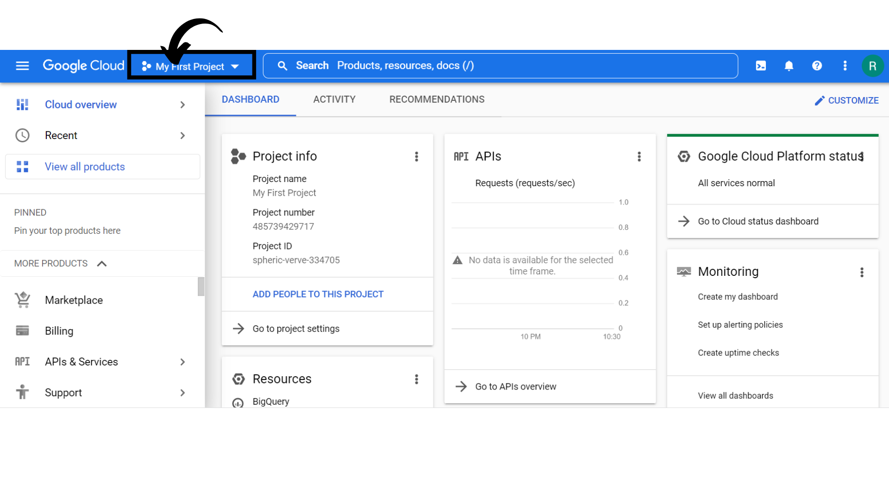

1. Click on the *“New Project”* button here.

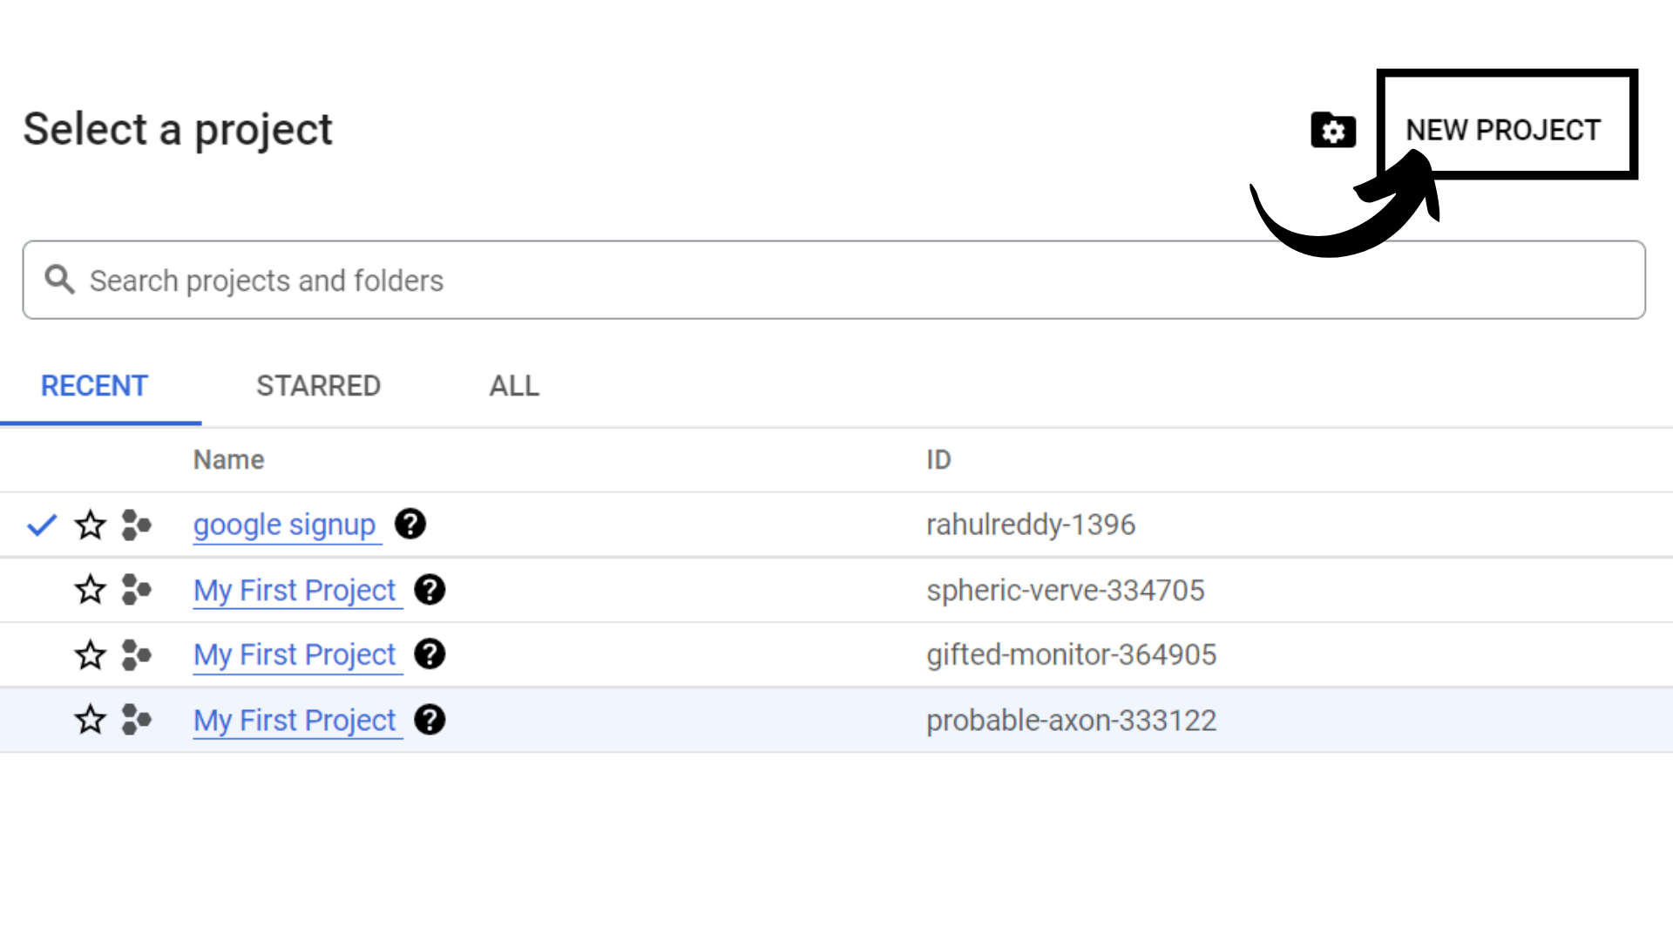

1. You can also create the project by clicking on *“IAM & Admin” → “Manage Resources”.*

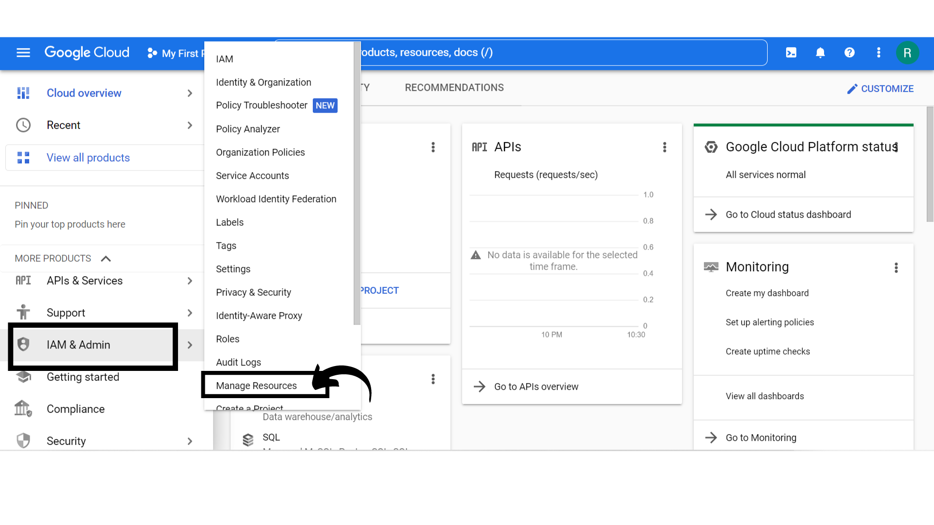

1. Your screen should look similar to this.

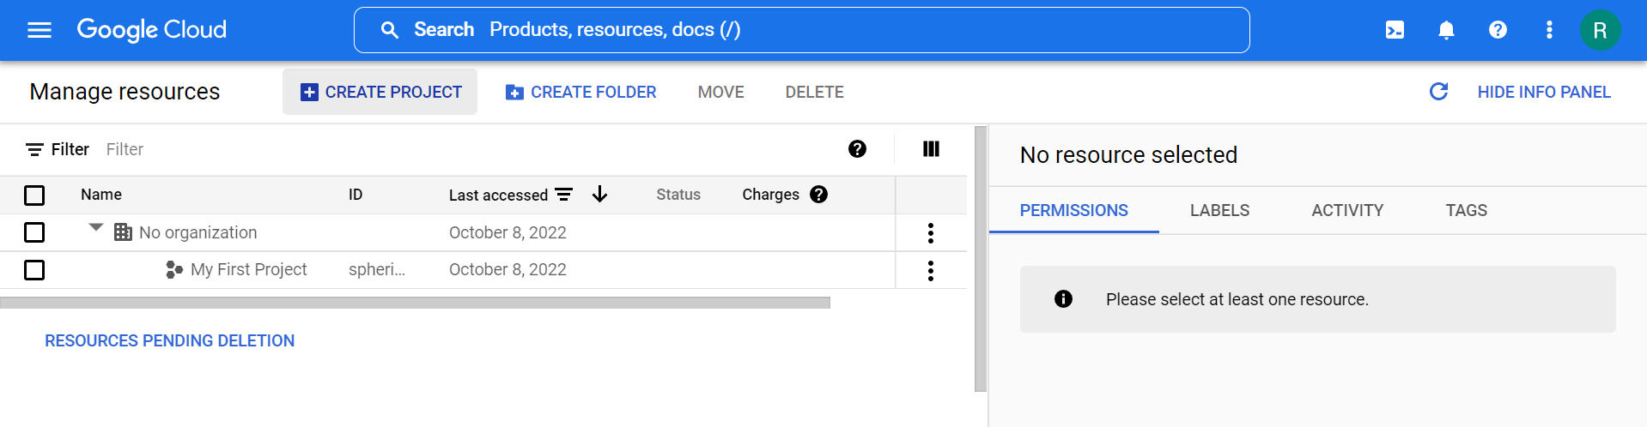

1. Click on *“Create Project”.*

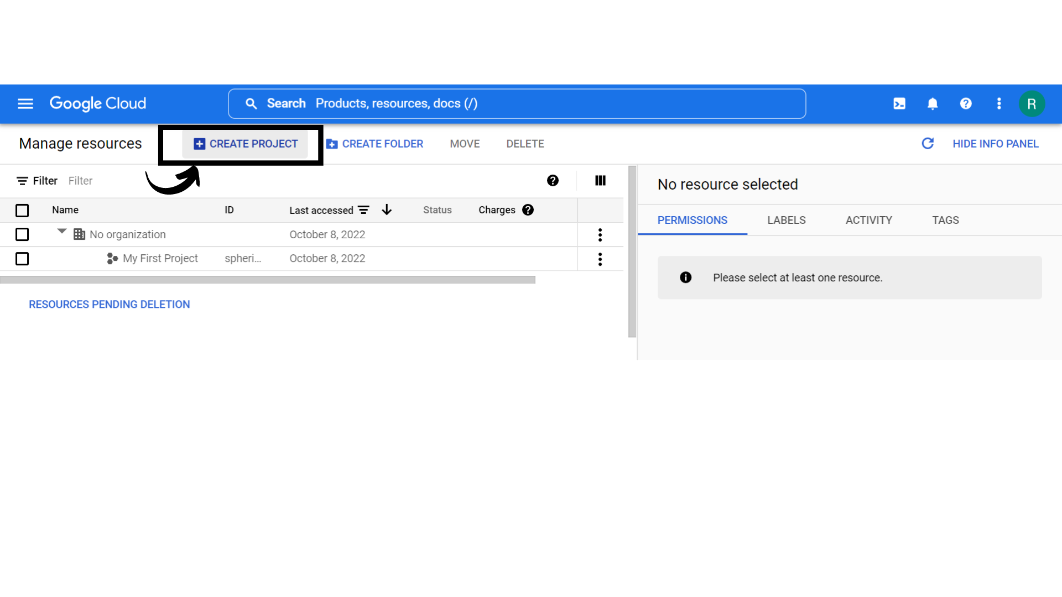

You will see all the Projects which have been created previously here.

1. Your screen should look similar to this.

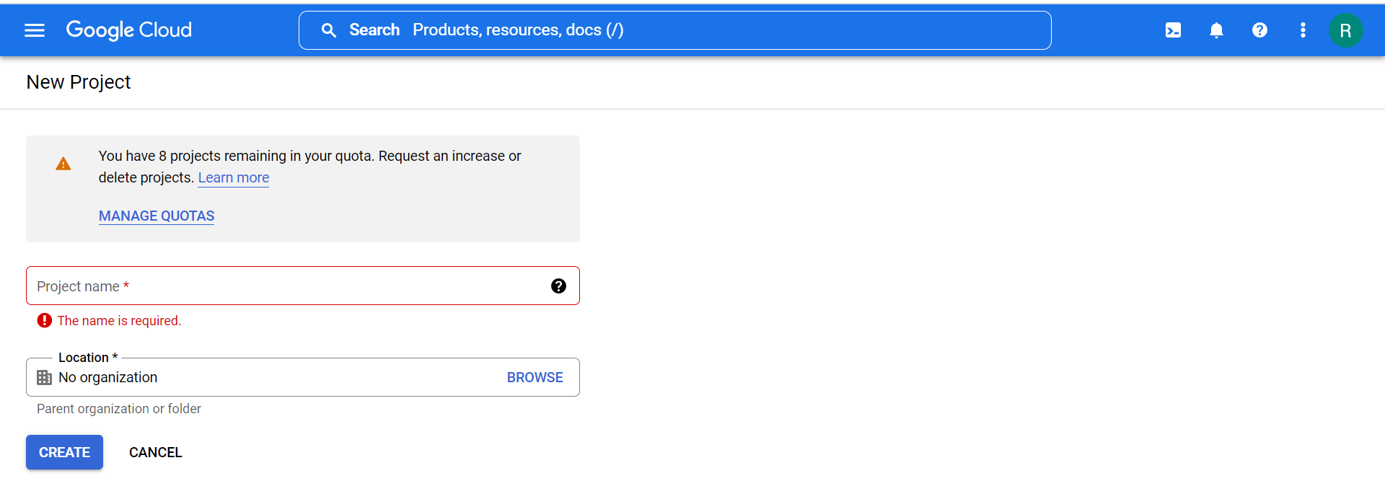

Click on *“Project name”.*

**Project name:** A human-readable name for your project.

Now it's time to pick a project name. This can be whatever you want. Usually, organizations will pick a name that describes what they are planning to build. For this example, let’s go with *“Security Labs”.*

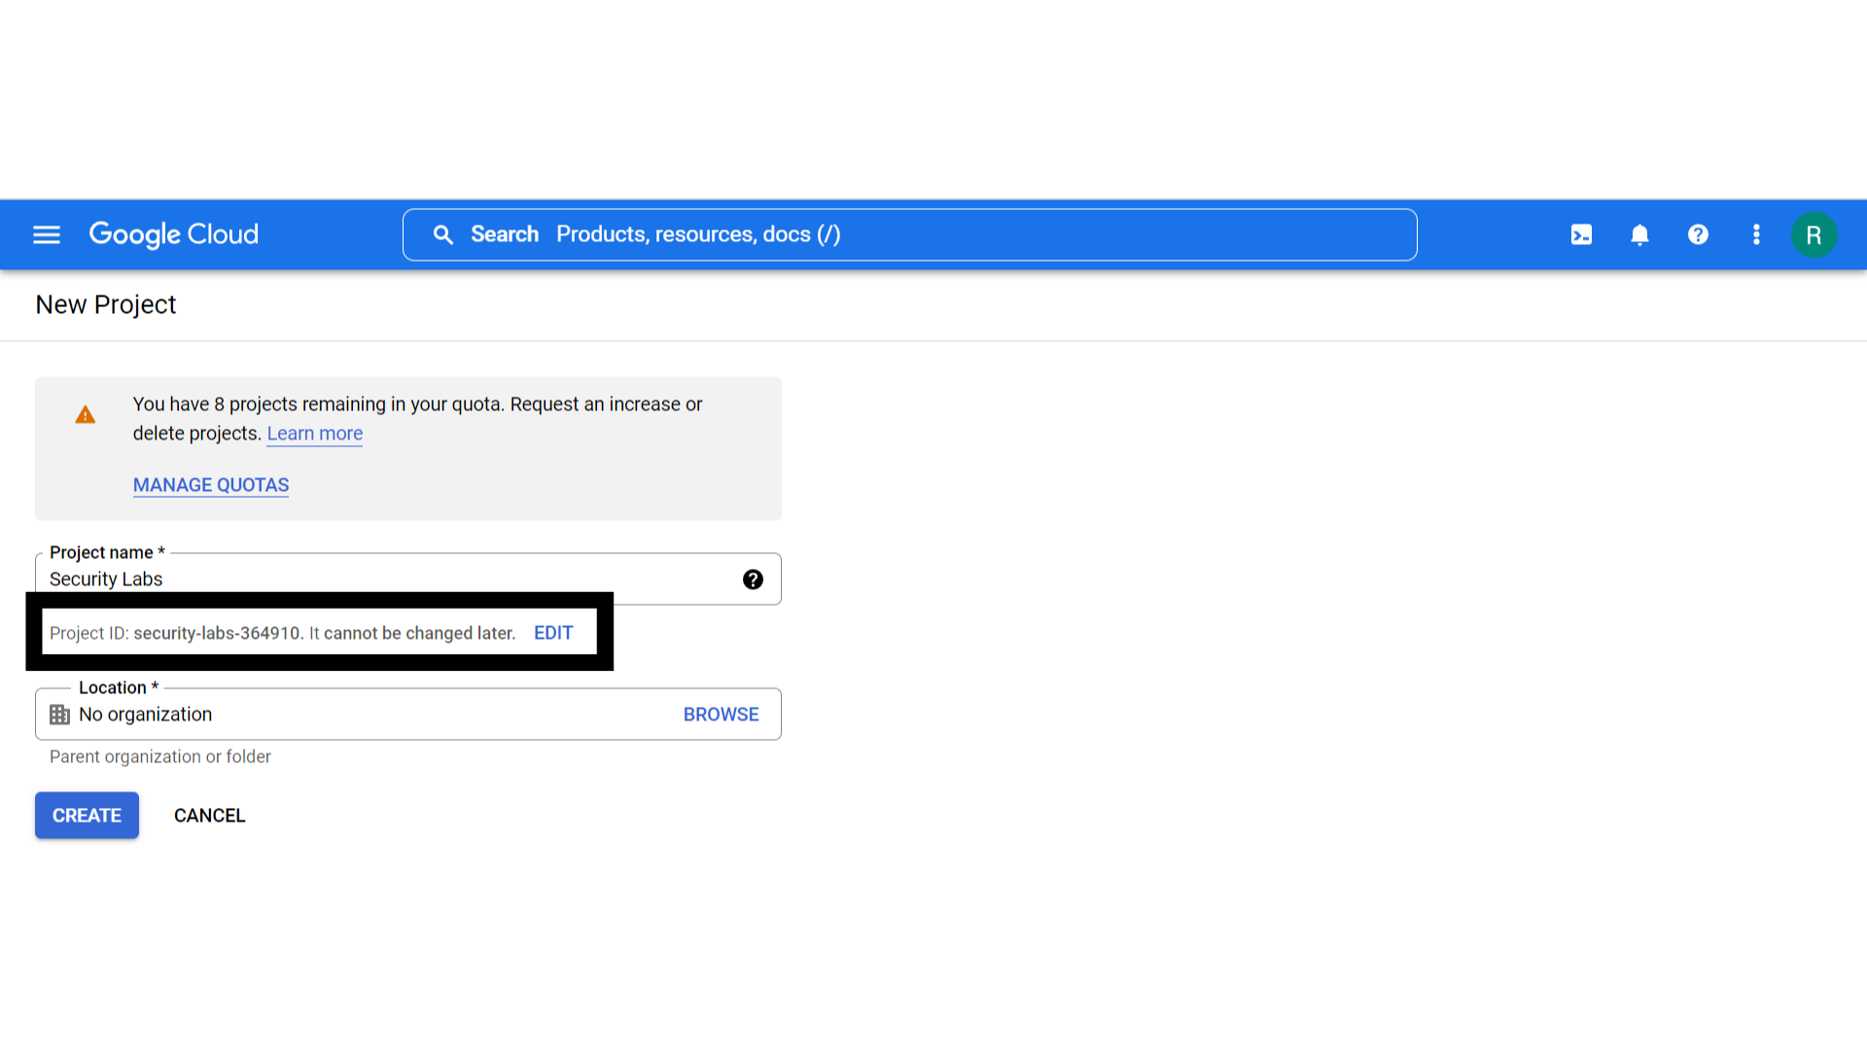

**Project ID:** A globally unique identifier for your project.

A project ID is a unique string used to differentiate your project from all others in Google Cloud. You can use the Google Cloud console to generate a project ID, or you can choose your own. You can only modify the project ID when you're creating the project.

1. Click on *“location”.* If you have a more complicated setup with folders or multiple organizations, you will need to pick the correct one. But since this is a new, personal account I don’t have any of that. I will just leave it set to the default and click on *“Create”.*

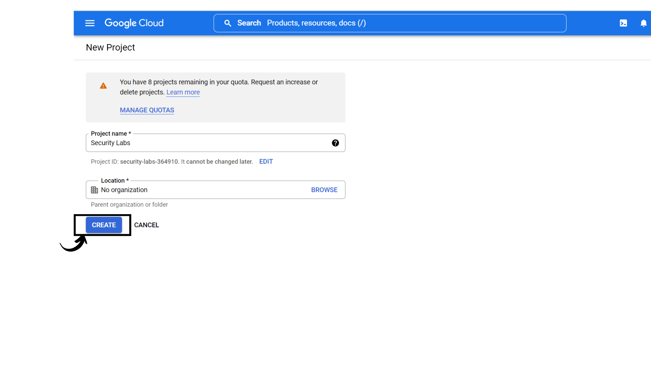

1. Your screen should look similar to this with the new project *“ Security labs”* created.

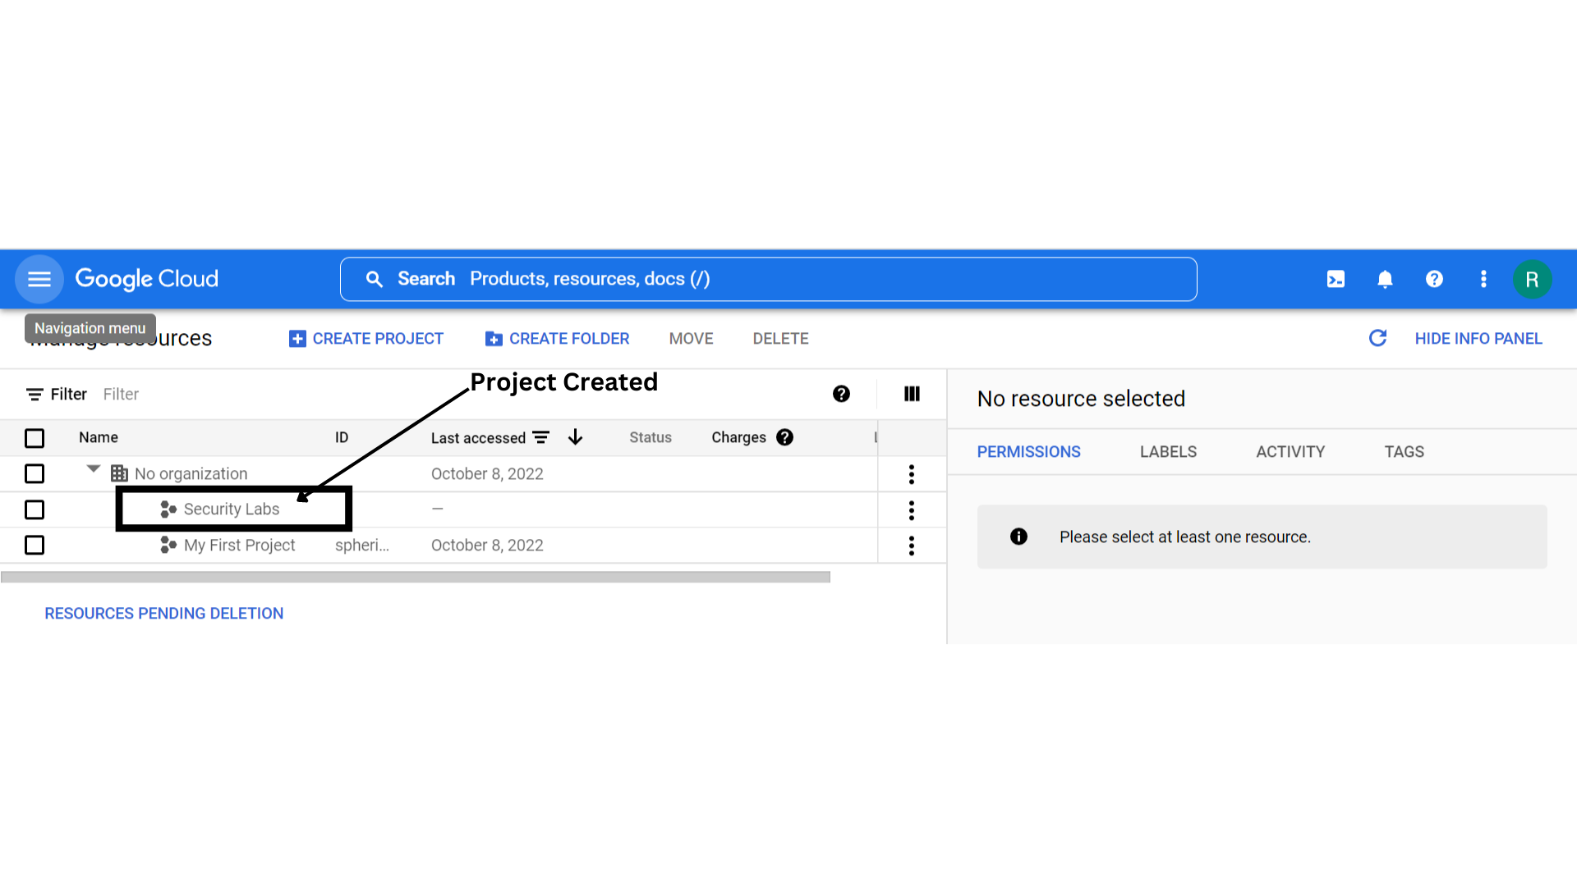

1. Now click on *“Google cloud”* to go to Dashboard.

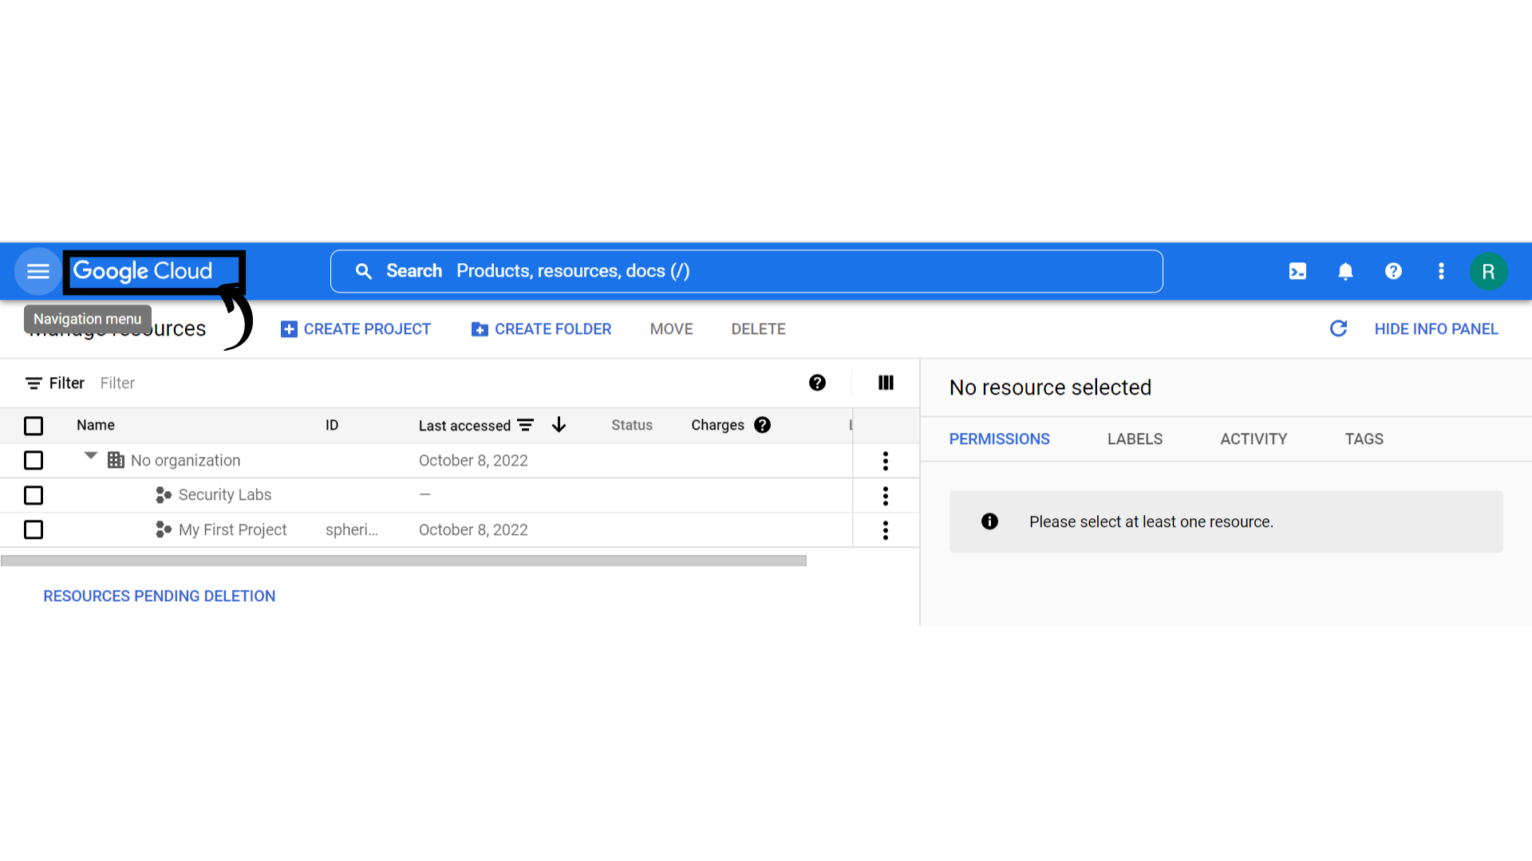

1. Your screen should look similar to this

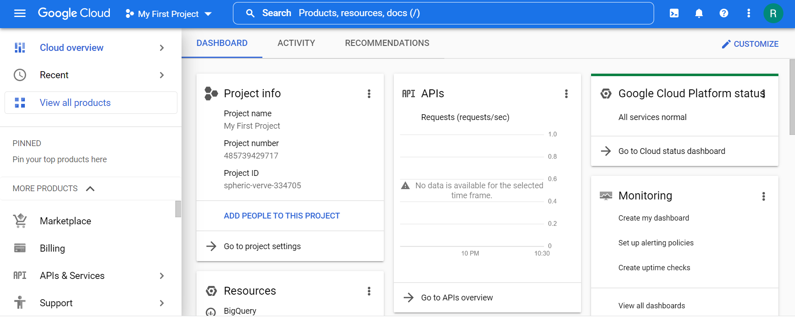

1. Click on the project selector drop-down menu at the top of the screen to switch the project you have created.



1. Your screen should look similar to this and select the project you have created.

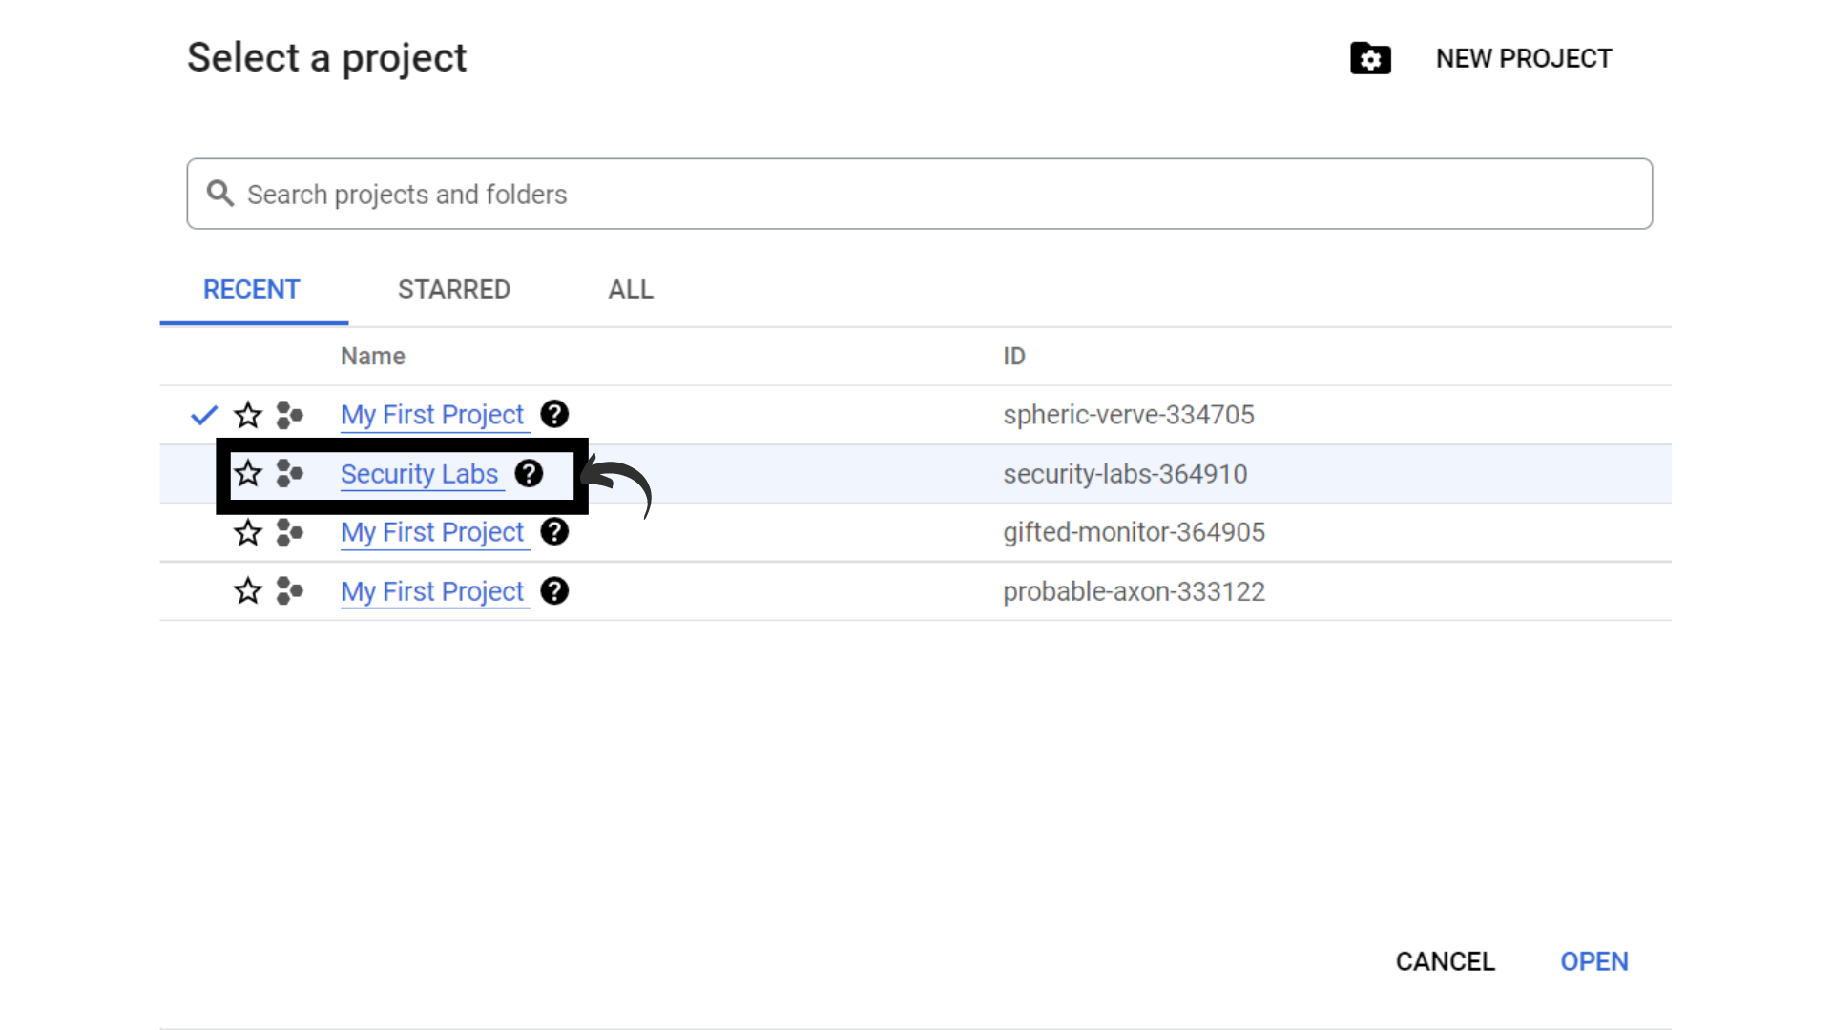

1. Now your screen should look similar to this with Project info.

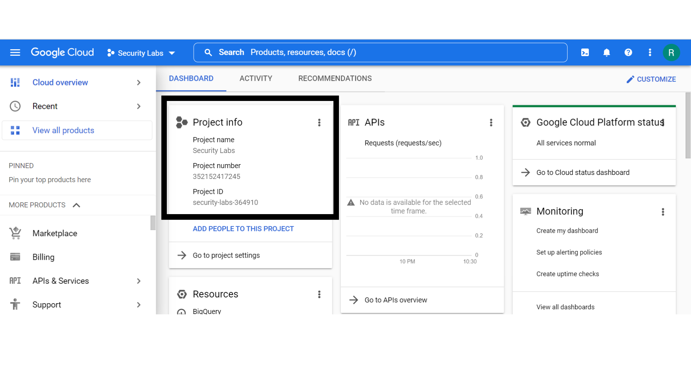

1. That’s it, A new project has been created.